RAJALAKSHMI ENGINEERING COLLEGE

**Name**

: . . . . . . . . . . . . . . . . . . . . . . . . . . . . . . . . . . . . . . . . . . . . .

**Register No**.

: . . . . . . . . . . . . . . . . . . . . . . . . . . . . . . . . . . . . . . . . . . . . .

**Year / Branch**:

. . . . . . . . . . . . . . . . . . . . . . . . . . . . . . . . . . . . . . . . . . . . .

**Semester**

: . . . . . . . . . . . . . . . . . . . . . . . . . . . . . . . . . . . . . . . . . . . . .

**Academic Year**

:

An Autonomous Institution, Affiliated to Anna University Rajalakshmi Nagar, Thandalam – 602 105



R-2023

V SEMESTER

B.Tech. – Artificial Intelligence & Data Science

**LABORATORY MANUAL**

**AD23532 – PRINCIPLES OF DATA SCIENCE**

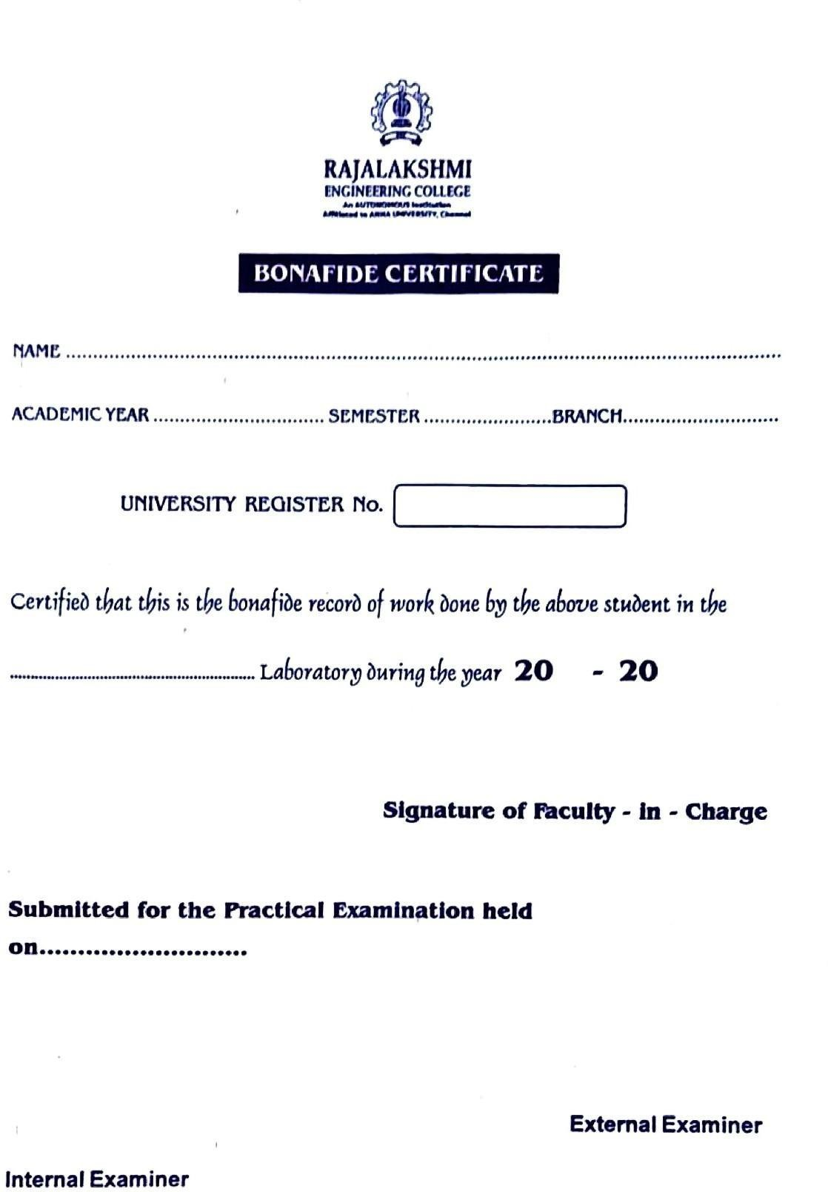

**INDEX**

|  |  |  |  |  |
| --- | --- | --- | --- | --- |
| **S. No.** | **Name of the Experiment** | **Date** | **Github QR** | **Faculty Sign** |
| 1 | Load Titanic dataset and convert to dataframe | 22/07/2025 |  |  |
| 2 | Data Analysis & Preprocessing | 22/07/2025 |  |  |
| 3 | Sales Prediction & Customer segmentation | 26/07/2025 |  |  |
| 4 | Text preprocessing & Analytics pipeline | 29/07/2025 |  |  |
| 5 | NLP Task- Parts of speech Tagging and Information retrieval | 02/08/2025 |  |  |

|  |  |  |  |  |
| --- | --- | --- | --- | --- |
| 6 | Exploratory Data Analysis | 12/08/2025 |  |  |
| 7 | K-Means Clustering | 16/09/2025 |  |  |
| 8 | Interactive Dashboards with Tableu | 27/09/2025 |  |  |
| 9 | PROJECT REPORT |  |  |  |